Design Principles - Open/Closed Principle (OCP)
# Source: AI Source: Provided by: [Data Path: Persons Table -> ID Column: 1, Name_En Column: Motasem Essam] -> From: [ChatGPT] on [1/23/2026]
The Open/Closed Principle states that software entities (classes, modules, functions) should be open for extension but closed for modification.
👉 Think of it like adding new apps to your phone without needing to rewrite the operating system — you extend functionality without touching existing code.

🔑 Key Points
# Source: AI Source: Provided by: [Data Path: Persons Table -> ID Column: 1, Name_En Column: Motasem Essam] -> From: [ChatGPT] on [1/23/2026]
• Open for extension: you can add new behavior
• Closed for modification: existing code should not be changed to add that behavior
• Promotes maintainability and stability
• Supports polymorphism and abstraction in object-oriented design

❌ Bad Example
# Source: AI Source: Provided by: [Data Path: Persons Table -> ID Column: 1, Name_En Column: Motasem Essam] -> From: [ChatGPT] on [1/23/2026]
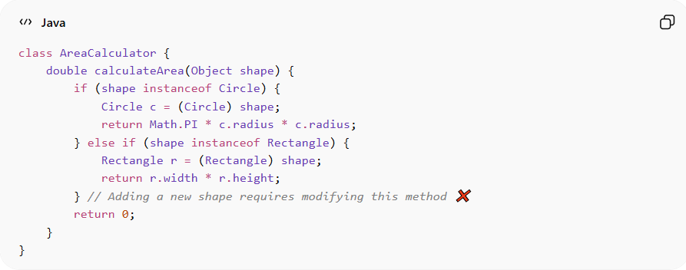
class AreaCalculator {
double calculateArea(Object shape) {
if (shape instanceof Circle) {
Circle c = (Circle) shape;
return Math.PI * c.radius * c.radius;
} else if (shape instanceof Rectangle) {
Rectangle r = (Rectangle) shape;
return r.width * r.height;
} // Adding a new shape requires modifying this method ❌
return 0;
}
}
Problems:
• Method must be modified to support new shapes
• Risks breaking existing code
• Violates OCP

✅ Good Example
# Source: AI Source: Provided by: [Data Path: Persons Table -> ID Column: 1, Name_En Column: Motasem Essam] -> From: [ChatGPT] on [1/23/2026]
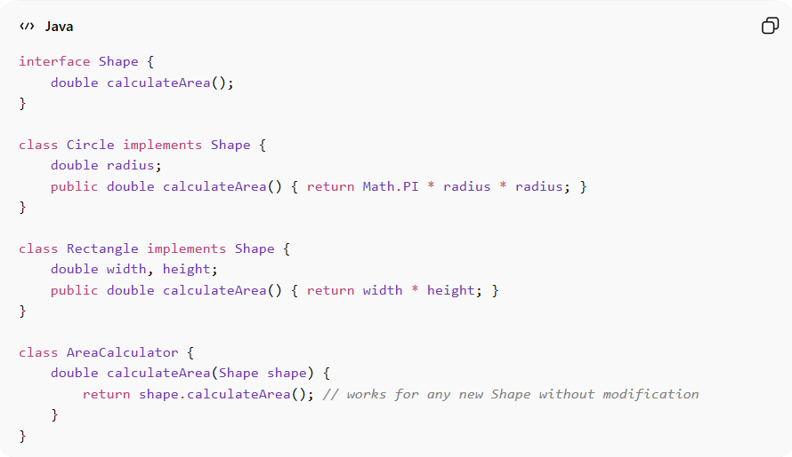
interface Shape {
double calculateArea();
}

class Circle implements Shape {
double radius;
public double calculateArea() { return Math.PI * radius * radius; }
}

class Rectangle implements Shape {
double width, height;
public double calculateArea() { return width * height; }
}

class AreaCalculator {
double calculateArea(Shape shape) {
return shape.calculateArea(); // works for any new Shape without modification
}
}
Benefits:
• New shapes can be added without changing existing code
• Reduces risk of bugs in tested code
• Supports extensible and maintainable architecture
• Promotes polymorphism and interface-based design

⚡ When to Apply
# Source: AI Source: Provided by: [Data Path: Persons Table -> ID Column: 1, Name_En Column: Motasem Essam] -> From: [ChatGPT] on [1/23/2026]
• Always — especially in systems that evolve frequently
• Useful when designing libraries, APIs, or frameworks
• Combine with SRP, DRY, and Dependency Inversion for robust OOP design
• Works well with interfaces and abstract classes

